**Name:** WASIMA QAYYUMUDDIN SHAIKH

**RollNo:**6220071

**Class:** T.E.I.T

**Sem:** V

**Subject:** ADVACE DEVOPS LAB **(Addevops**)

**EXPERIMENT NO: 14**

**Q1. What is Nagios? Comment on why we need Nagios tool?**

Nagios is an open source software for continuous monitoring of systems, networks, and infrastructures. It runs plugins stored on a server which is connected with a host or another server on your network or the Internet. In case of any failure, Nagios alerts about the issues so that the technical team can perform recovery process immediately.



Nagios is used for Continuous monitoring of systems, applications, services, and business processes etc in a DevOps culture. In the event of a failure, Nagios can alert technical staff of the problem, allowing them to begin remediation processes before outages affect business processes, end-users, or customers. With Nagios, you don’t have to explain why an unseen infrastructure outage affect your organization’s bottom line.

Nagios runs on a server, usually as a daemon or a service. It periodically runs plugins residing on the same server, they contact hosts or servers on your network or on the internet. One can view the status information using the web interface. You can also receive email or SMS notifications if something happens.

The Nagios daemon behaves like a scheduler that runs certain scripts at certain moments. It stores the results of those scripts and will run other scripts if these results change.

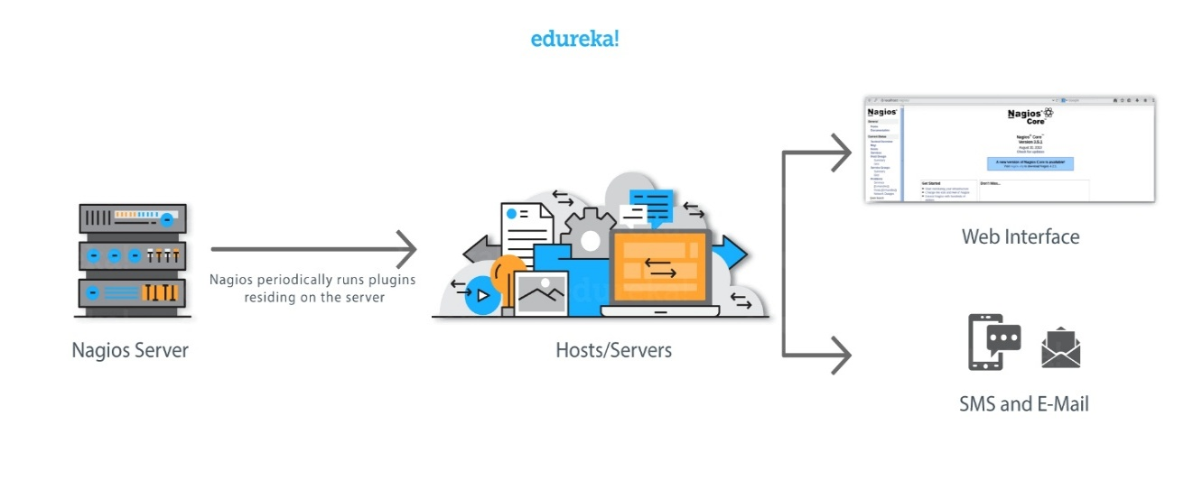

Plugins: These are compiled executables or scripts (Perl scripts, shell scripts, etc.) that can be run from a command line to check the status or a host or service. Nagios uses the results from the plugins to determine the current status of the hosts and services on your network.

**Why We Need Nagios tool?**

Here are the important reasons to use Nagios monitoring tool:

1. Provide all types of network or server issues Helps you to find the root cause of the problem which allows you to get the permanent solution to the problem
2. Active monitoring of your entire infrastructure and business processes
3. Allows you to monitors and troubleshoot server performance issues
4. Helps you to plan for infrastructure upgrades before outdated systems create failures
5. You can maintain the security and availability of the service
6. Automatically fix problems in a panic situation

**Q2. Perform an experiment, to Understand Continuous monitoring and Installation and configuration of Nagios Core, Nagios Plugins on Linux Machine.**

1. Create EC2 instance Service → EC2 →Launch Instance

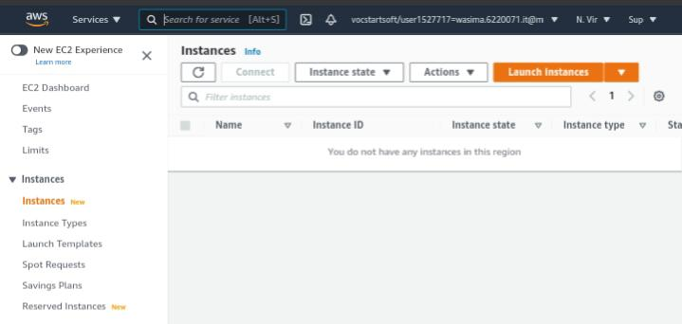

1. 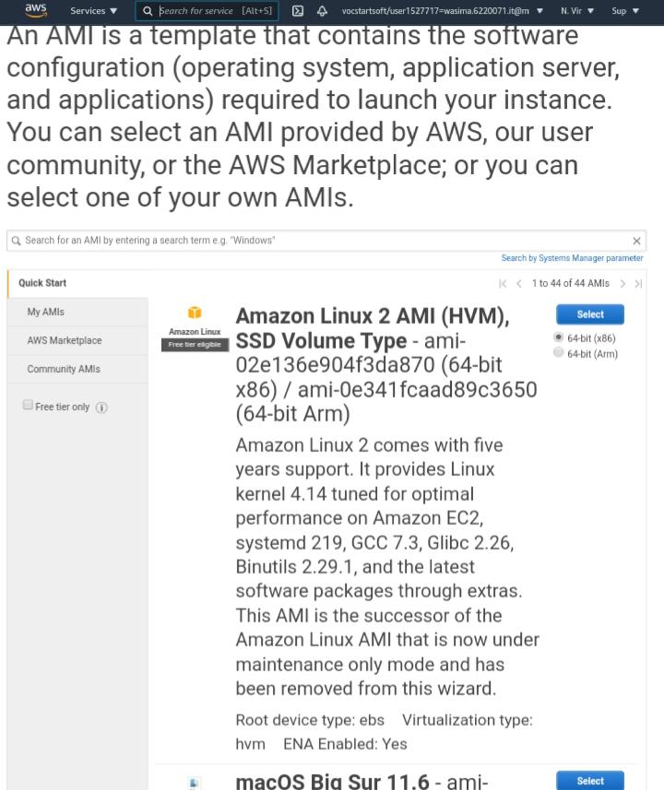Then choose AMI here we are choosing Linux Server.
2. Then in Configure Security Group → Add Rule → (All Traffic)

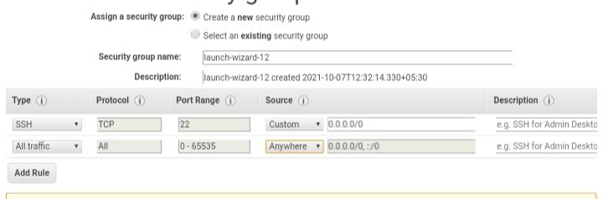

1. Then review and launch by downloading key-value pair

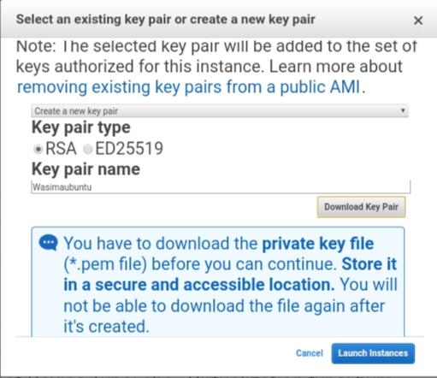

1. After launching the instance, we need to connect to our instance by clicking on connect. Then we need to select SSH client.

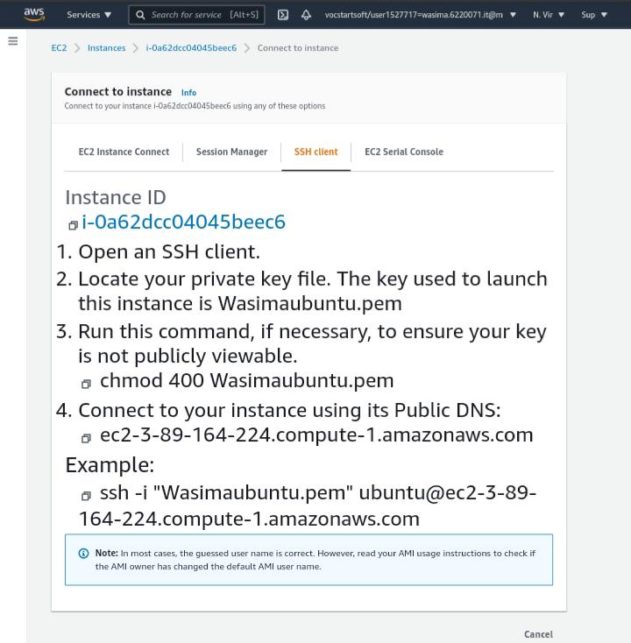

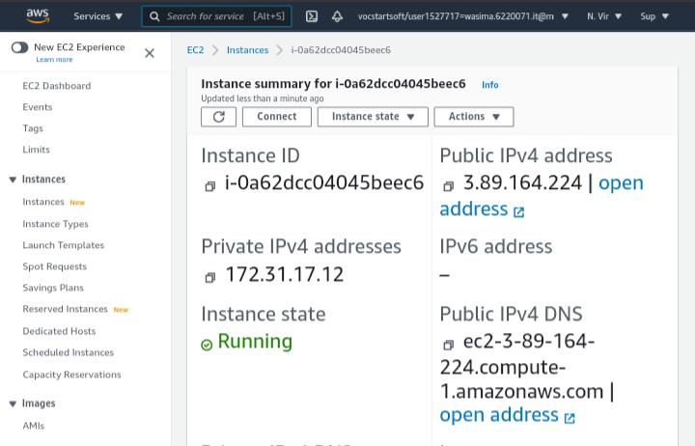

1. After that open Termux qpp -> locate private key file by using cd command 🡪 Execute chmod 400 wasima12.pem for publically viewable to connect instance execute command ssh -I “wasima12.pem” and it’s Public DNS.

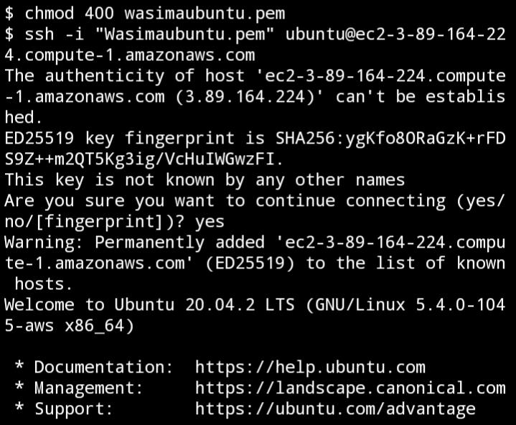

1. Then type ‘sudo su’ for entering root user. Than Install dependencies for nagios by executing following command

Yum install httpd php

Yum install gcc glibc glibc-common

Yum install gd gd-devel

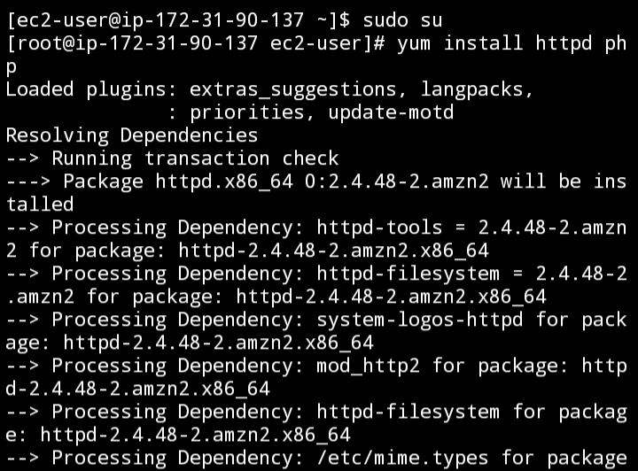

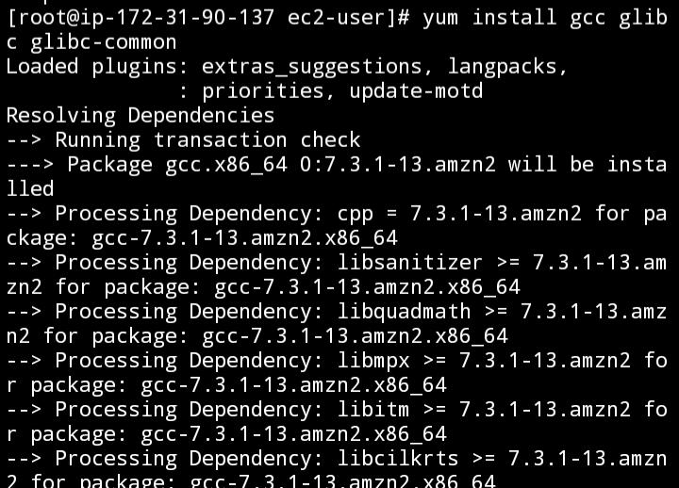

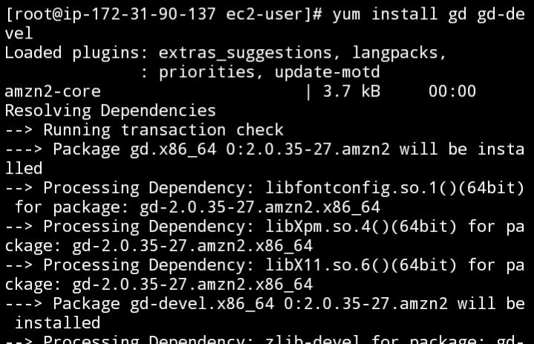

1. Add username and specify password for the nagios.

Adduser -m nagios

Passwd nagios

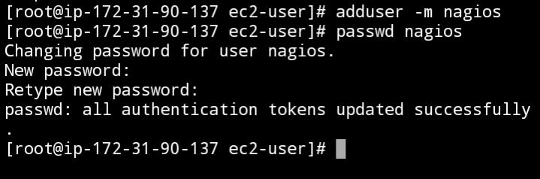

1. Add group by executing the command

Groupadd nagioscmd

Usermod -a -G nagioscmd nagios

Usermod -a -G nagioscmd apache

And make 1 directory named as downloads and change director to download.

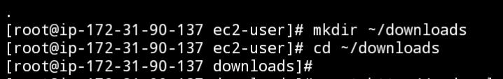

1. Download nagios by using the command

Wget http://prdownloads.sourceforge.net/sourceforge/nagios/nagios-4.0.8.tar.gz

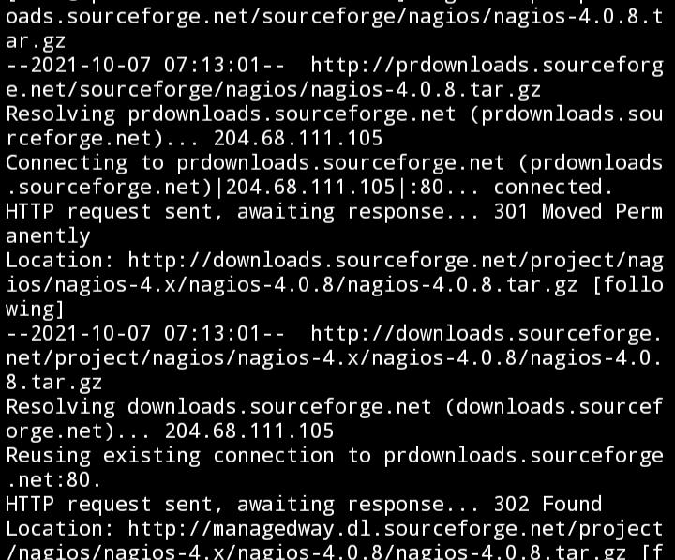

1. Download nagios plugin by wget command and specifying it’s url.

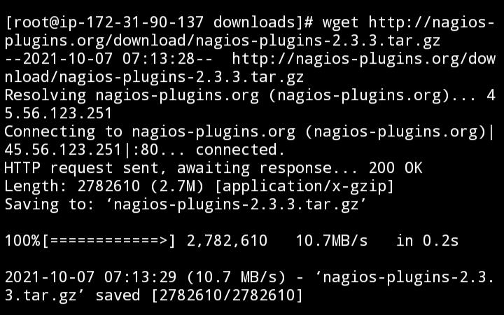Wget <http://nagios-plugins.org/download/nagios-plugins-2.3.3.tar.gz>

1. Then run following commands

Tar zxvf nagios-4.0.8.tar.gz

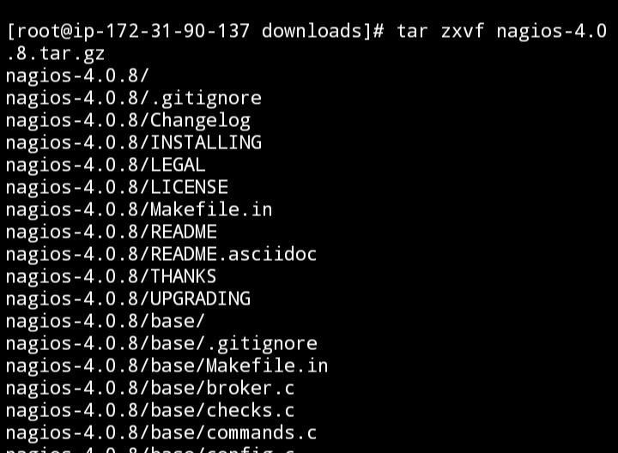

Cd nagios-4.0.8

./configure –with-command-group=nagioscmd

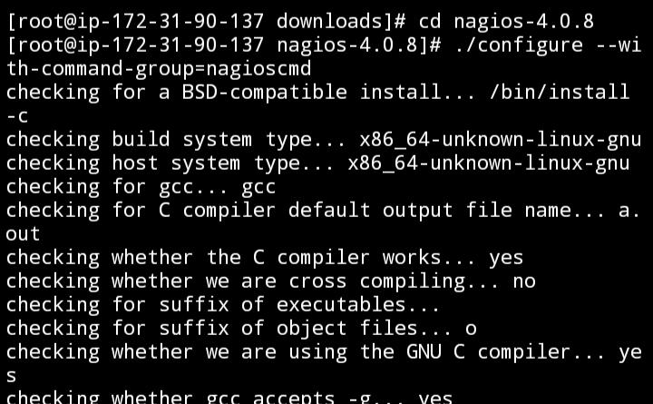

Make all

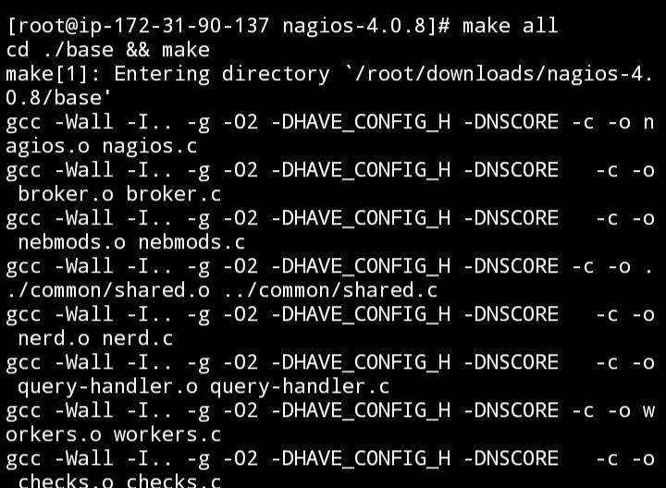

Make install

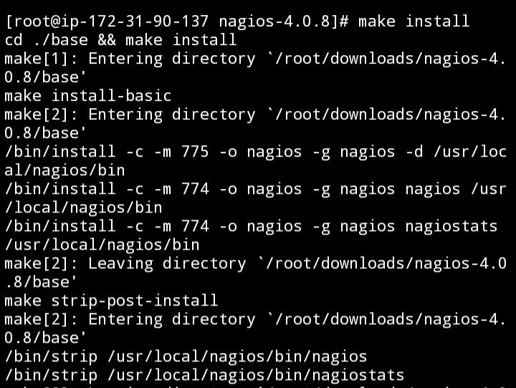

Make install-init

Make install-config

Make install-commandmode

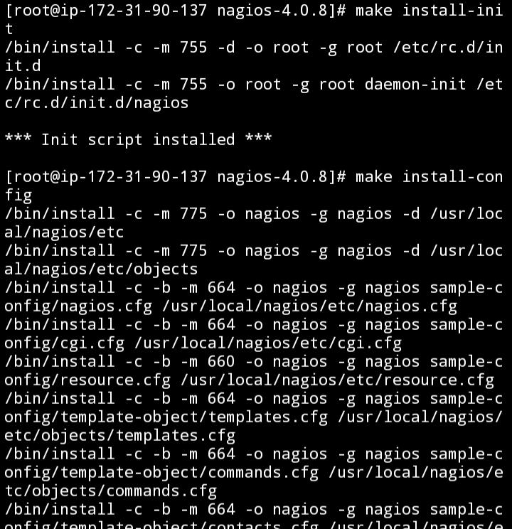

Make install-webconf

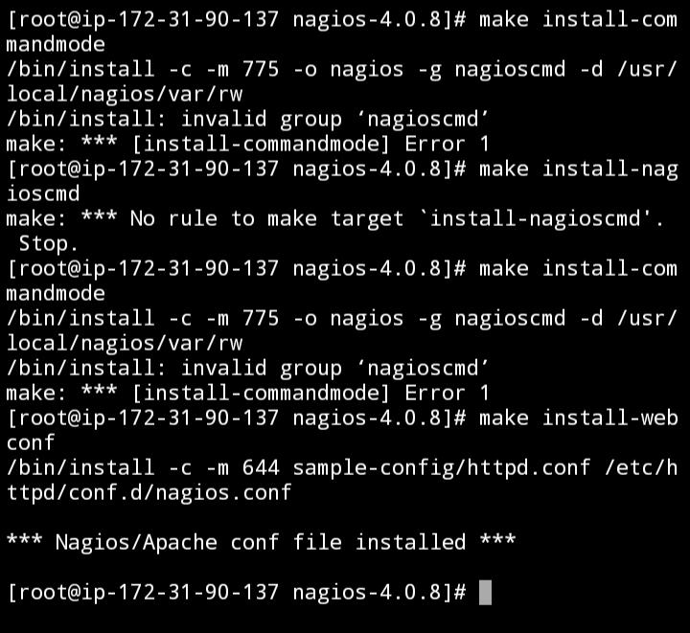

1. Specify the addmin username and password this is used when login nagios.

Htpasswdd -c /usr/local/nagios/etc/htpasswd.users nagiosadmin

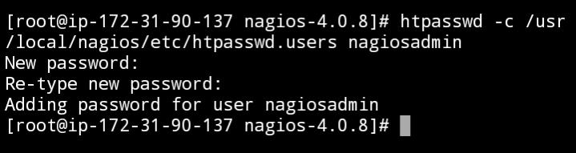

1. Then run following commands

Service httpd restart

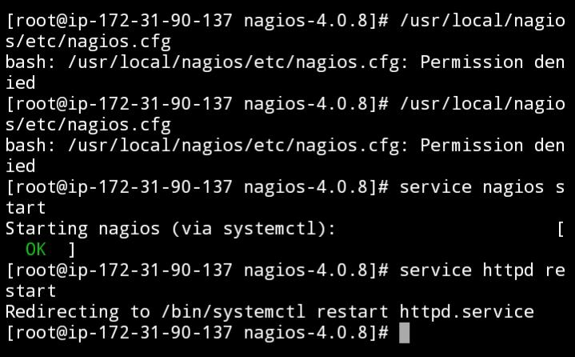

Cd ~/downloads



Tar zxvf nagios-plugins-2.3.3.tar.gz



Cd nagios-plugins-2.3.3

./configure –with-nagios-user=nagios –with-nagios-group=nagios

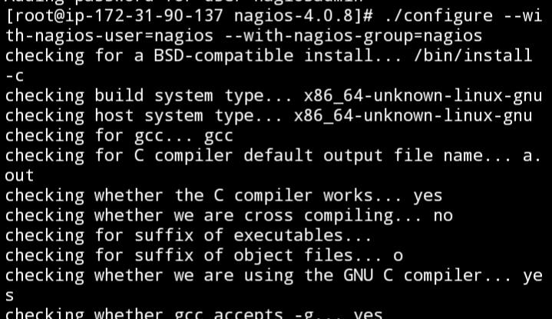

Make

Make install

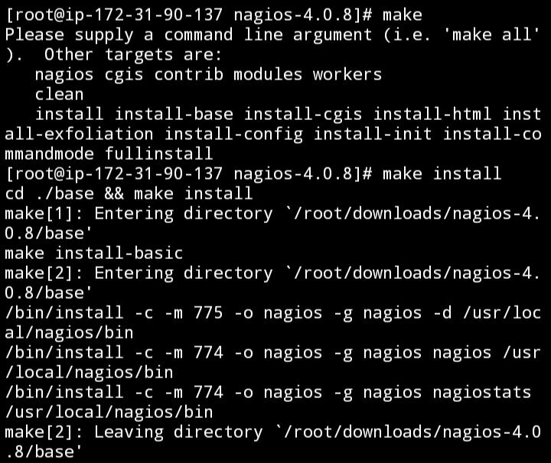

Chkconfig –add nagios

Chkconfig nagios on

/usr/local/nagios/bin/nagios -v

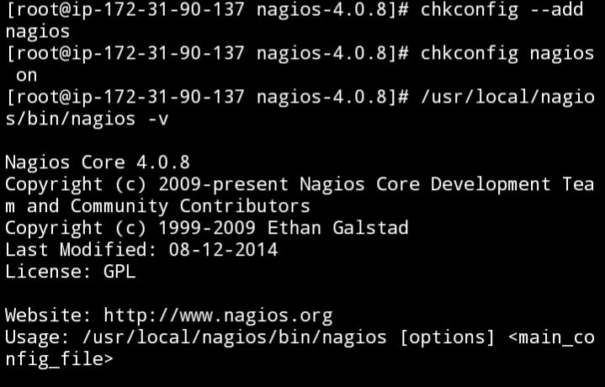

/usr/local/nagios/etc/nagios.cfg

Service nagios start

Service httpd restart



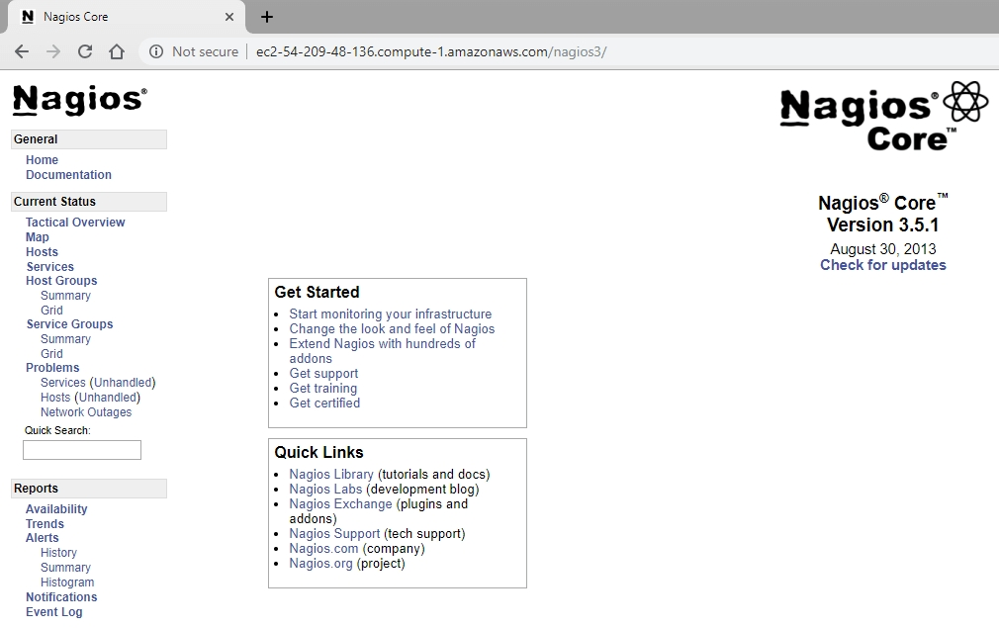

**Q3. CoreNagios dashboard and just list any 5 services available of dashboard.**

* Detailed menu

Nagios XI provides several options for viewing host and service details in Your monitoring environment. Details can be viewed by:

* + Individual Hosts or Services
  + Host or Service Group Summaries
  + Host or Service Group Overviews
  + Host or Service Group Grids

You can access the Details menu by clicking on the Home menu item, Then select the Details sub-menu to select your different viewing options.

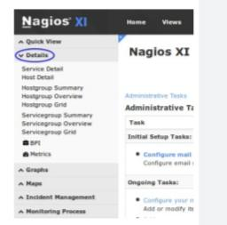

* Service Detail

The Service Detail page displays a complete list of all services currently being monitored in a table format. Services are color-coded based on their status.

To see more information about a particular service, click a link in the Service column to access the Service Status Detail page.

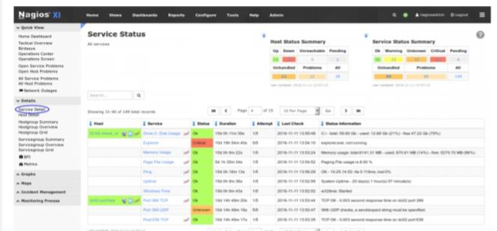

* Host Detail

The Host Detail page displays a complete list of all hosts currently being monitored in a table format. Hosts Are color-coded based on their status. To see more information about a particular host, click a link in the Host Column to access the Host Status Detail page.

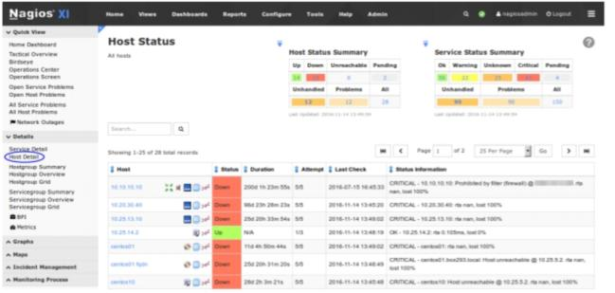

* Hostgroup Summary and Servicegroup Summary

Host groups and Service groups created in CCM will be presented in a summary table. The Hosts and Services columns provide a breakdown of the objects, clicking the numbers will take you to the status screen Filtered to that type.

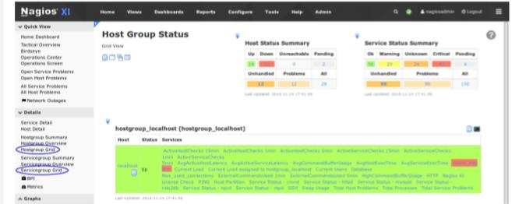

**Note: Terminate the resources after performing the practical- terminate Ec2**